1. INTRODUCTION

1.1overview

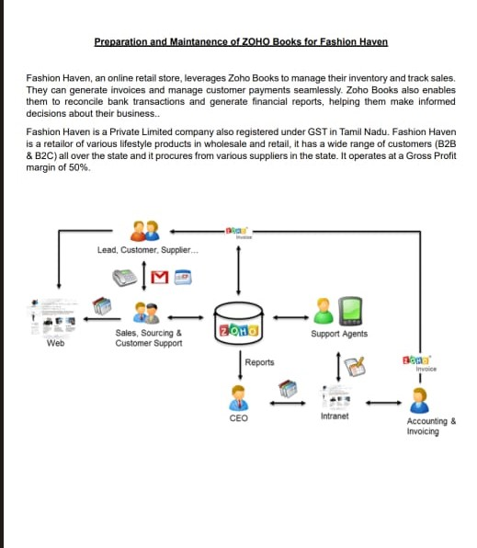 Description of the project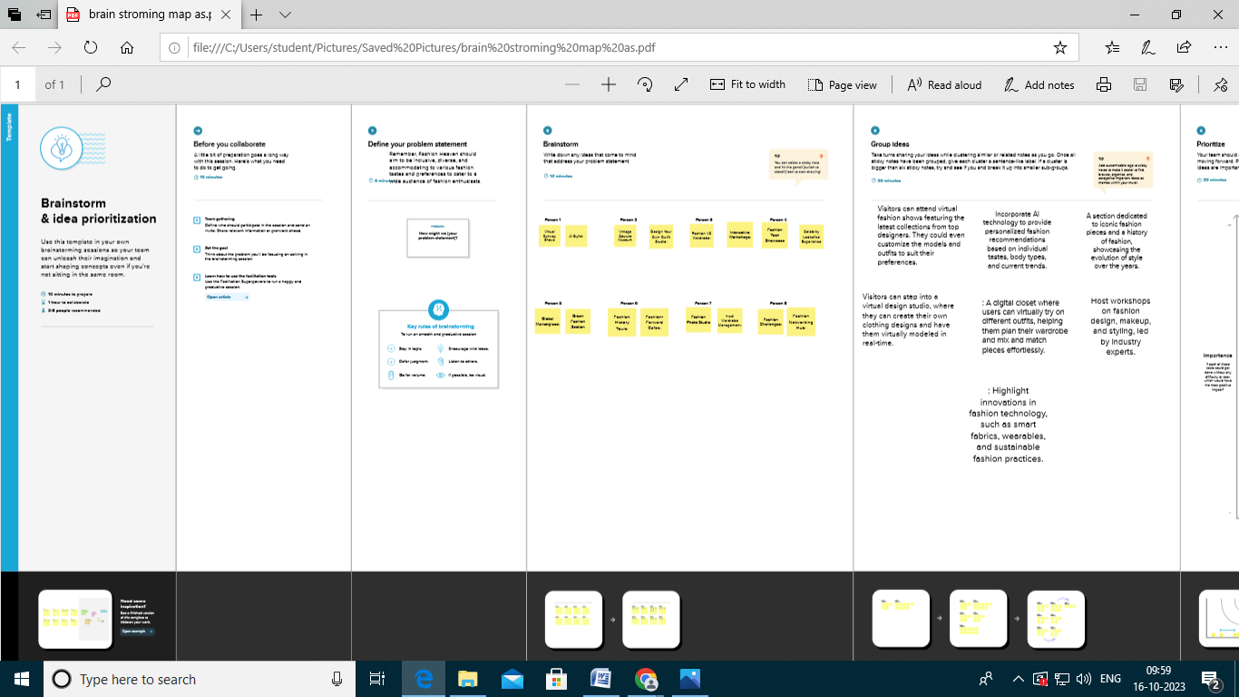

## 2.Problem definition & design thinking

2.1 empathy map

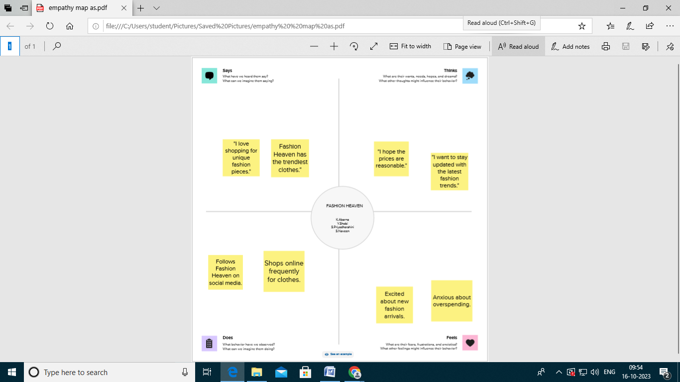

2.2 Ideation & Brainstorming Map

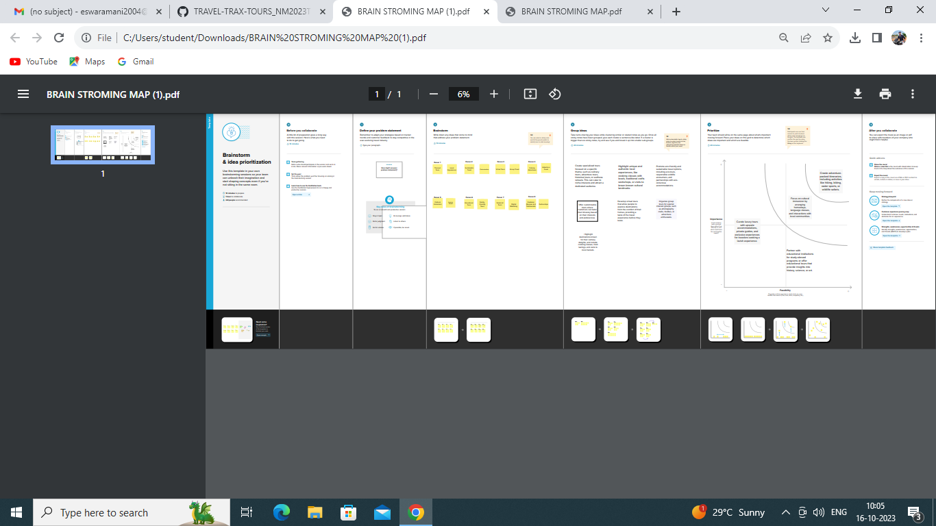

3.RESULT

Profit & loss

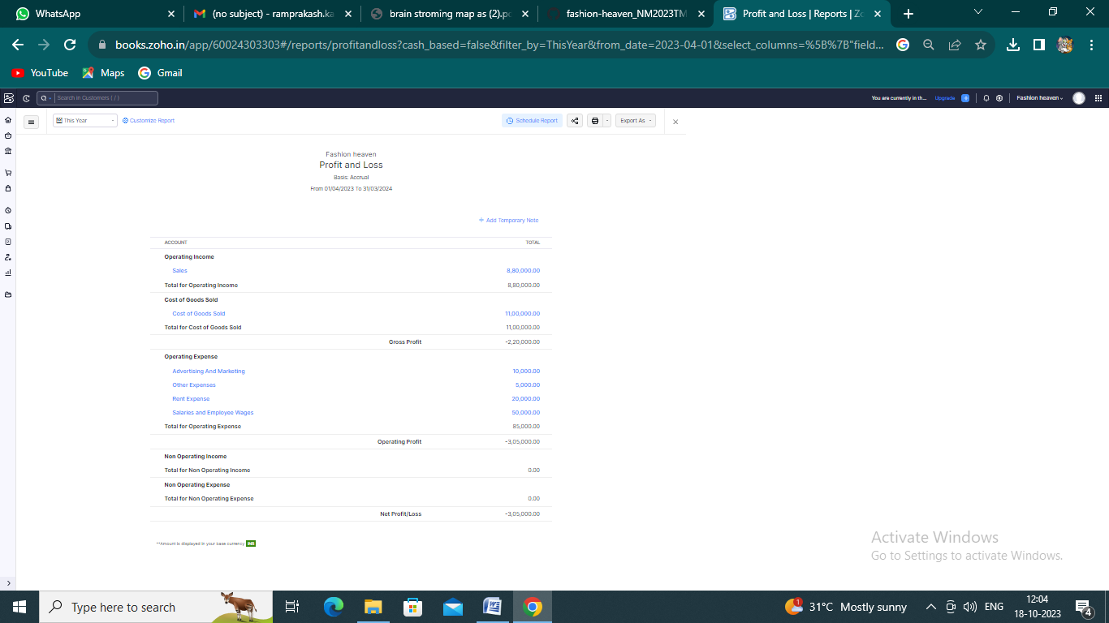

# Balance sheet :

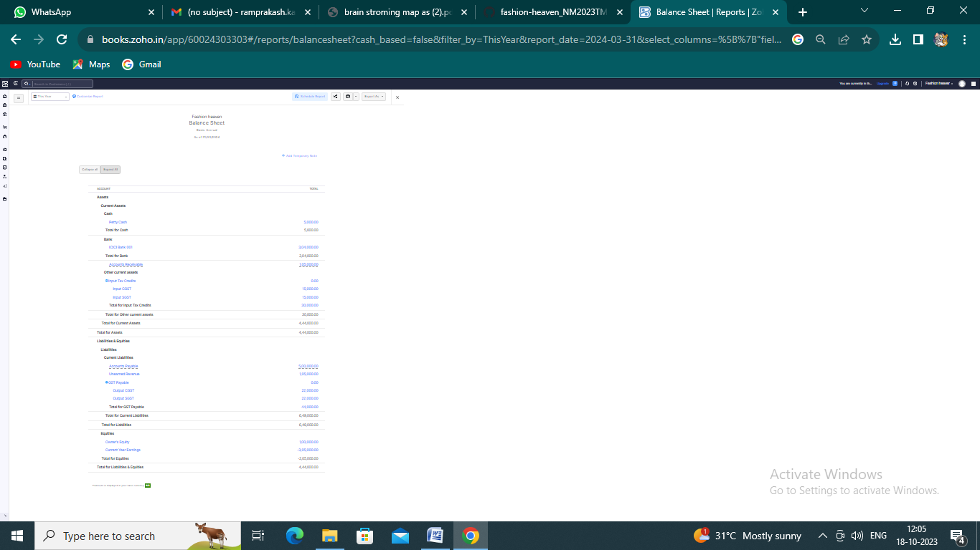

# Purchase order :

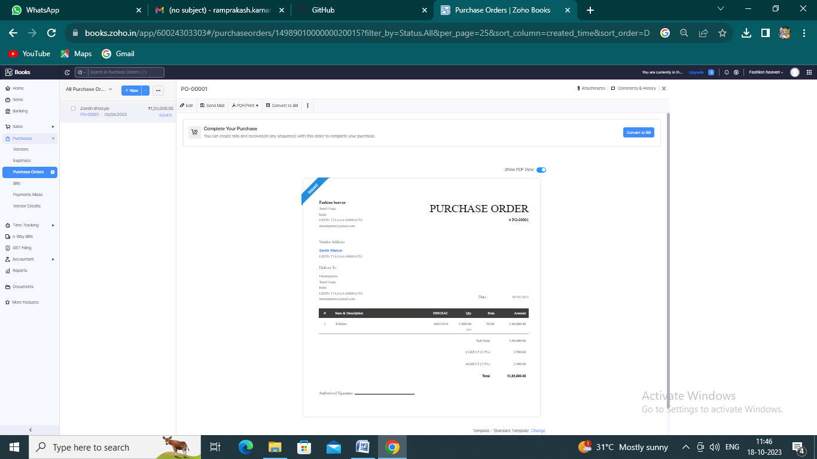

## BILLS :

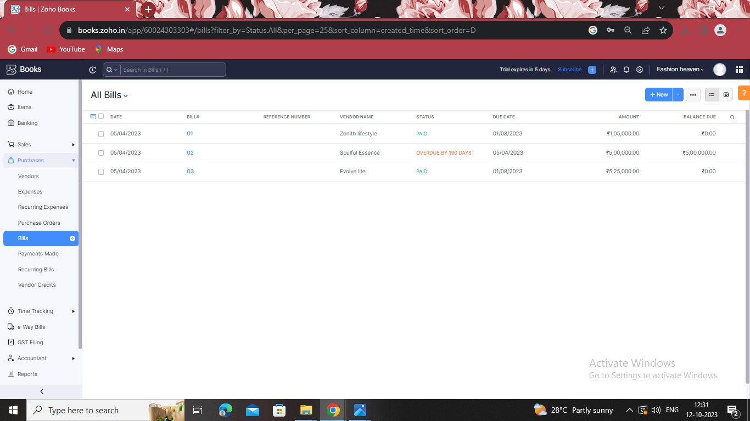

## SALES ORDERS :

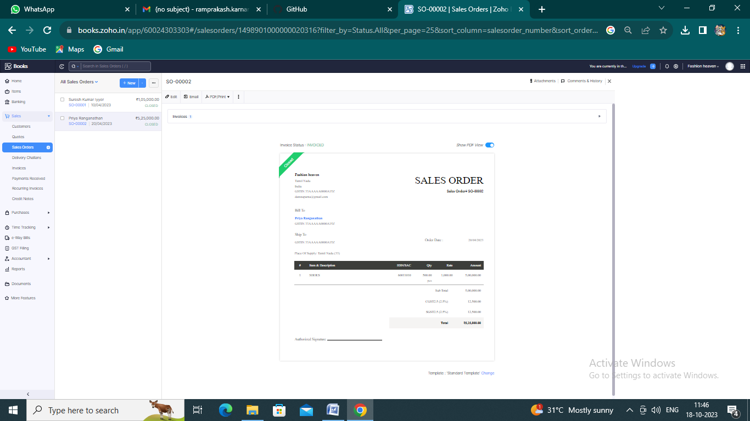

## INVOICE :

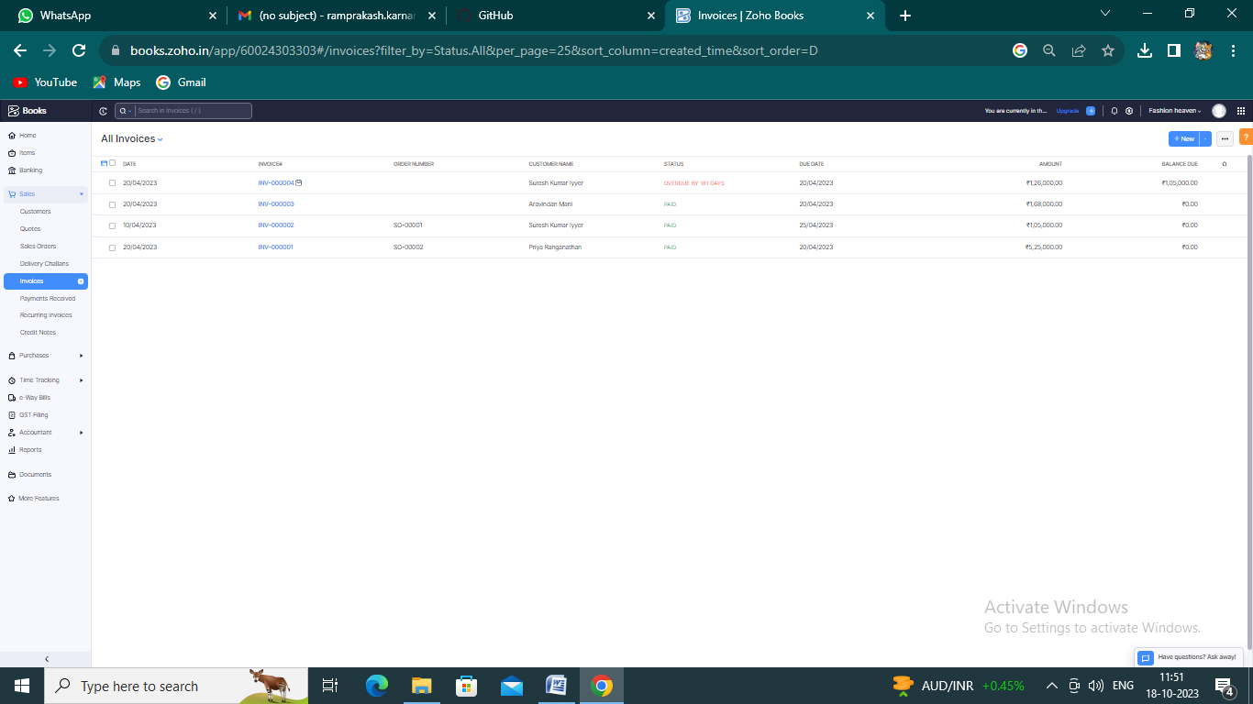

# ADVANTAGES OF FASHION HEAVEN :

1. When a fashionist finds women clothing that fits them and makes them look and feel great, that brings a sense of accomplishment and personal fulfillment. There are hardly any things that can feel like such a win than buying and wearing amazing clothes that complement your figure and completely match your vibe and style expectations.
2. Women’s fashion could be perceived as a form of creativity. For designers, fashion is the craft of creating art in the form of wearable clothing. For the wearers, it is a way to creatively twist concepts and combine garments to make incredible outfits work. Needless to say, it encourages women to be more unique and expressive with the way they chose to dress.
3. Let’s not forget that women’s fashion also brings joy and excitement. Dressing up could be an excellent idea to lift your spirits or keep up a good mood, as it has the power to make you feel great about yourself. The whole process of browsing, trying on, purchasing, styling, and wearing clothes is known to boost dopamine for most people interested in fashion

# DISADVANTAGES OF FASHION HEAVEN :

1. Expense: Following fashion trends often requires frequent wardrobe updates, which can be costly and unsustainable for some individuals.
2. Environmental Impact: Fast-changing trends contribute to the "throwaway culture," leading to increased textile waste and environmental pollution.
3. Pressure to Conform: Fashion trends can create social pressure to conform, leading to a lack of individuality and self-expression.

# 4.APPENDIX :

<https://github.com/abarnateamhead/fashion-heaven_NM2023TMID22780>

|  |
| --- |
| <!DOCTYPE html> |
|  | <html lang="en" data-color-mode="auto" data-light-theme="light" data-dark-theme="dark" data-a11y-animated-images="system" data-a11y-link-underlines="false"> |
|  |  |
|  | <style> |
|  | /* for each iteration, uncomment the CSS variable */ |
|  |  |
|  | /* light themes */ |
|  | [data-color-mode="light"][data-light-theme*="light"], |
|  | [data-color-mode="auto"][data-light-theme*="light"] { |
|  | /* iteration 1 */ |
|  | --border-color-iteration-1: #C8CCD0; |
|  | /* iteration 2 */ |
|  | --border-color-iteration-2: #BABFC5; |
|  | /* iteration 3 */ |
|  | --border-color-iteration-3: #A6ADB4; |
|  | /* iteration final */ |
|  | --border-color-iteration-4: #868F99; |
|  |  |
|  | /* the first value is the final step, which falls back to previous iterations */ |
|  | --control-borderColor-rest: var(--border-color-iteration-4, var(--border-color-iteration-3, var(--border-color-iteration-2, var(--border-color-iteration-1)))) !important; |
|  | } |
|  |  |
|  | /* dark themes */ |
|  | [data-color-mode="dark"][data-dark-theme*="dark"], |
|  | [data-color-mode="auto"][data-light-theme*="dark"] { |
|  | /* iteration 1 */ |
|  | --border-color-iteration-1: #363940; |
|  | /* iteration 2 */ |
|  | --border-color-iteration-2: #3F434B; |
|  | /* iteration 3 */ |
|  | --border-color-iteration-3: #4B5159; |
|  | /* iteration final */ |
|  | --border-color-iteration-4: #666E79; |
|  |  |
|  | /* the first value is the final step, which falls back to previous iterations */ |
|  | --control-borderColor-rest: var(--border-color-iteration-4, var(--border-color-iteration-3, var(--border-color-iteration-2, var(--border-color-iteration-1)))) !important; |
|  | } |
|  |  |
|  | [data-color-mode="dark"][data-dark-theme="dark_dimmed"], |
|  | [data-color-mode="dark"][data-dark-theme="light_high_contrast"], |
|  | [data-color-mode="dark"][data-dark-theme="dark_high_contrast"], |
|  | [data-color-mode="light"][data-light-theme="dark_dimmed"], |
|  | [data-color-mode="light"][data-light-theme="light_high_contrast"], |
|  | [data-color-mode="light"][data-light-theme="dark_high_contrast"] { |
|  | /* skip these themes, use the fallback */ |
|  | --control-borderColor-rest: initial !important; |
|  | } |
|  |  |
|  | @media (prefers-color-scheme: dark) { |
|  | /* dark colors in dark mode */ |
|  | [data-color-mode="auto"][data-dark-theme*="dark"] { |
|  | /* iteration 1 */ |
|  | --border-color-iteration-1: #363940; |
|  | /* iteration 2 */ |
|  | --border-color-iteration-2: #3F434B; |
|  | /* iteration 3 */ |
|  | --border-color-iteration-3: #4B5159; |
|  | /* iteration final */ |
|  | --border-color-iteration-4: #666E79; |
|  |  |
|  | /* the first value is the final step, which falls back to previous iterations */ |
|  | --control-borderColor-rest: var(--border-color-iteration-4, var(--border-color-iteration-3, var(--border-color-iteration-2, var(--border-color-iteration-1)))) !important; |
|  | } |
|  |  |
|  | /* light colors in dark mode */ |
|  | [data-color-mode="auto"][data-dark-theme*="light"] { |
|  | /* iteration 1 */ |
|  | --border-color-iteration-1: #C8CCD0; |
|  | /* iteration 2 */ |
|  | --border-color-iteration-2: #BABFC5; |
|  | /* iteration 3 */ |
|  | --border-color-iteration-3: #A6ADB4; |
|  | /* iteration final */ |
|  | --border-color-iteration-4: #868F99; |
|  |  |
|  | /* the first value is the final step, which falls back to previous iterations */ |
|  | --control-borderColor-rest: var(--border-color-iteration-4, var(--border-color-iteration-3, var(--border-color-iteration-2, var(--border-color-iteration-1)))) !important; |
|  | } |
|  |  |
|  | [data-color-mode="auto"][data-dark-theme="dark_dimmed"], |
|  | [data-color-mode="auto"][data-dark-theme="light_high_contrast"], |
|  | [data-color-mode="auto"][data-dark-theme="dark_high_contrast"] { |
|  | /* skip these themes, use the fallback */ |
|  | --control-borderColor-rest: initial !important; |
|  | } |
|  | } |
|  |  |
|  | @media (prefers-color-scheme: light) { |
|  | /* dark colors in light mode */ |
|  | [data-color-mode="auto"][data-light-theme*="dark"] { |
|  | /* iteration 1 */ |
|  | --border-color-iteration-1: #363940; |
|  | /* iteration 2 */ |
|  | --border-color-iteration-2: #3F434B; |
|  | /* iteration 3 */ |
|  | --border-color-iteration-3: #4B5159; |
|  | /* iteration final */ |
|  | --border-color-iteration-4: #666E79; |
|  |  |
|  | /* the first value is the final step, which falls back to previous iterations */ |
|  | --control-borderColor-rest: var(--border-color-iteration-4, var(--border-color-iteration-3, var(--border-color-iteration-2, var(--border-color-iteration-1)))) !important; |
|  | } |
|  |  |
|  | /* light colors in light mode */ |
|  | [data-color-mode="auto"][data-light-theme*="light"] { |
|  | /* iteration 1 */ |
|  | --border-color-iteration-1: #C8CCD0; |
|  | /* iteration 2 */ |
|  | --border-color-iteration-2: #BABFC5; |
|  | /* iteration 3 */ |
|  | --border-color-iteration-3: #A6ADB4; |
|  | /* iteration final */ |
|  | --border-color-iteration-4: #868F99; |
|  |  |
|  | /* the first value is the final step, which falls back to previous iterations */ |
|  | --control-borderColor-rest: var(--border-color-iteration-4, var(--border-color-iteration-3, var(--border-color-iteration-2, var(--border-color-iteration-1)))) !important; |
|  | } |
|  |  |
|  | [data-color-mode="auto"][data-light-theme="dark_dimmed"], |
|  | [data-color-mode="auto"][data-light-theme="light_high_contrast"], |
|  | [data-color-mode="auto"][data-light-theme="dark_high_contrast"] { |
|  | /* skip these themes, use the fallback */ |
|  | --control-borderColor-rest: initial !important; |
|  | } |
|  | } |
|  | </style> |